**Force Sensitive Resistor**

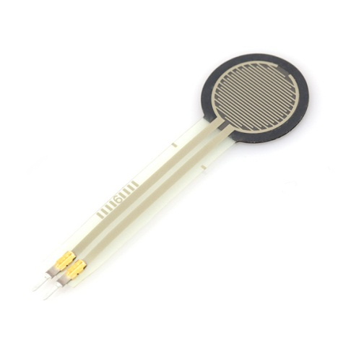

**What It Does**: The Force Sensitive Resistor (FSR) is a sensor that changes its resistance when pressed. The change in resistance can be measured by the Arduino can be used to determine the force applied to it.

**What It Tells You**: The greater that value reported by the FSR, the harder it is being pressed. The sensor will report 0 if untouched. While it is possible to convert this value to a physical unit such as pounds, we have not done this in our exercise.

**Required Connections**: For this workshop, the FSR should already be wired up, but you may need to attach the connections to your Arduino. The red wire is for power and should be connected to **5V**. The black wire is ground and should be connected to **Ground/GND**. A third wire (of another color) should be connected to an **Analog Input**.

**Using the FSR in Scratch**:

Use a *value of sensor* block to read in from the selected Analog Input. Adjust the pull down menu in the block to select the proper pin.

E:\My Dropbox\PhD\IDSA Workshop\Images\valueOfBlock.png

Figure 1: Read Data from Analog Input 0

Also, it will be helpful to store the reading into an appropriately named variable.

E:\My Dropbox\PhD\IDSA Workshop\Images\ReadInForce.png

Figure 2: Read Sensor Measurement into a Variable

In the example below, the value of the sensor is read in and display on the right panel using the *say* block. We also use a *join* block to place the phrase “Force: “ in front of the sensor readings.

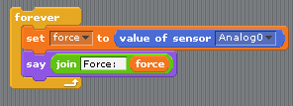

Figure 3: Reading the FSR Value from the Arduino’

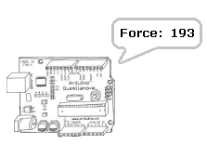

Figure 4: Arduino Printing Out "Force: " and the Value of the Sensor